Instructions for a No Sew T- Shirt Bag
If you have an old t-shirt which you or another family member no longer need then here are the instructions for how you can use it to make a reusable bag without having to do any sewing. (Unless you want to of course!)
Step 1: Cut both sleeves off. (Remember to ask
an adult to help with the cutting as you will
need sharp scissors.)

Step 2: Cut Off the Neckline.
Note: If you do not want a fringe at the bottom
of your bag then turn the t-shirt inside out at
this stage. Then after tying the fringe together
you can turn it back again so the fringe will be
inside and out of sight.
Step 3: Cut strips approximately 1 ½ - 2cm apart
and 5-8cm long to make a fringe at the bottom of
the t-shirt.

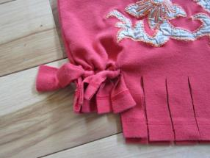
Step 4: Tie the fringes together in pairs with a
double knot.

Step 5: Finish Your Bag.
(If you enjoy sewing, you might like to add additional decorations!)

