Why do we use palm oil?
Palm oil is used in many of the products on supermarket shelves, from margarine and chocolate to ice cream, soaps, cosmetics, and fuel for cars and power plants. The reason why palm oil is so popular is because:
It has great cooking properties – it maintains its properties even under high temperatures.
Its smooth and creamy texture and absence of smell make it a perfect ingredient in many recipes, including baked goods (such as biscuits) in particular.
It has a natural preservative effect which extends the shelf life of food products.
It is also the highest-yielding vegetable oil crop, which makes it very efficient. It needs less than half the land required by other crops to produce the same amount of oil. This makes palm oil the least expensive vegetable oil in the world.
India, China, Indonesia and Europe are the main consumers of palm oil. It is estimated that a French person consumes on average 2 kg of palm oil per year, or 6% of total fat consumption of an adult between the ages of 18 and 72 (source: Fonds Français pour l’Alimentation et la Santé, Etat des lieux, November 2012).
http://www.rspo.org/about/sustainable-palm-oil

What is the impact of palm oil farming on the environment?
In some regions, oil palm cultivation has caused – and continues to cause – deforestation. This means that land, which was once predominantly covered by primary forest (forest that has never been touched by man) or which housed protected species and biodiversity, was cleared in order to be converted into palm oil plantations.
Likewise, some palm oil plantations were developed without consulting local communities over the use of their land. Some have even been responsible for forcibly displacing people from their land. Violations of workers’ rights to fair payment and safe working conditions and other malpractices have also occurred.
Despite widely-reported malpractices in the industry, a growing number of players in the palm oil industry have committed to adopting more sustainable practices. The result of this gradual transition is an increasing amount of palm oil in our products that has been produced and sourced in a sustainable manner.

Why is palm oil bad? (From WWF)
The oil palm tree only grows in tropical areas. Vast plantations have been established in such regions – on land that was often previously covered in high conservation value tropical forests. Such forests not only have the most species of trees per hectare, but a huge amount of other biodiversity as well.
Most of the world's oil palm trees are grown on a few islands in Malaysia and Indonesia – islands with the most biodiverse tropical forests found on Earth, and where there is a direct relationship between the growth of oil palm estates and deforestation.
Large-scale conversion of tropical forests to oil palm plantations has a devastating impact on a huge number of plant and animal species.
Deforestation can also cause soil erosion and contribute to air pollution and climate change. The practice of draining and converting peatland forests is especially damaging for the climate, as these “carbon sinks” store more carbon per unit area than any other ecosystem in the world.

Why can't we simply replace palm oil?
Although using other vegetable oils seems like a practical solution, it would actually create similar - if not even larger - environmental and social problems. Therefore, the best solution is to ensure you buy products that contain sustainable palm oil.
There is a misconception that these concerns can be addressed when companies simply stop using palm oil in their products. However, this is not as easy as it sounds for a number of reasons:
Replacing palm oil with other types of vegetable oil (such as sunflower, soybean or rapeseed oil) would mean that much larger amounts of land would need to be used, since palm trees produce 4-10 times more oil than other crops per unit of cultivated land. This would result in serious environmental damage, with the risk that more forests would need to be converted into agricultural land.
In producing countries, millions of farmers and their families work in the palm oil sector. Palm oil plays an important role in the reduction of poverty in these areas. In Indonesia and Malaysia, a total of 4.5 million people earn their living from palm oil production. Stopping the production of palm oil altogether would create significant problems for these people who support their families by working in this industry.
Replacing palm oil with other types of oil is not always feasible due to palm oil’s unique properties as food ingredient. Using other oils would not give the products the same texture and taste that palm oil offers.

What is the RSPO (RoundTable on sustainable palm oil)
The RSPO (set up initially by WWF and including a board with 4 NGOs) have become the leading initiative to support sustainable palm oil. Members have to sign up to their principles.

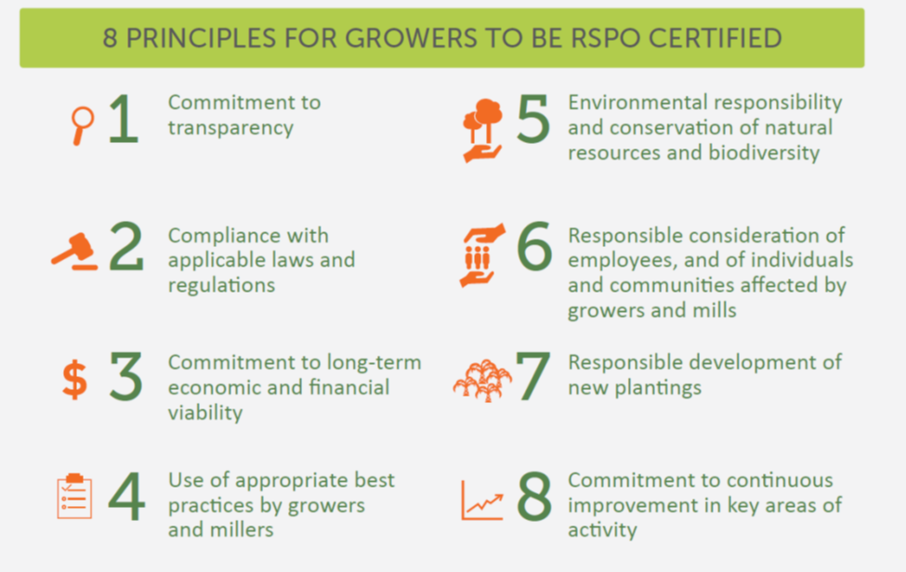
Also available in full here: http://www.rspo.org/key-documents/certification/rspo-principles-and-criteria

What is sustainable palm oil?
There are four methods of certification: book and claim / identity preserved / segregated / mass balanced. Book and claim is run by greenpalm.
http://greenpalm.org/about-greenpalm/what-is-green-palm

Supply chain definitions
https://rspo.org/certification/supply-chains
Book & Claim
The supply chain is not monitored for the presence of sustainable palm oil. Manufacturers and retailers can buy Credits from RSPO-certified growers, crushers and independent smallholders.
Mass Balance
Sustainable palm oil from certified sources is mixed with ordinary palm oil throughout supply chain.
Segregated
Sustainable palm oil from different certified sources is kept separate from ordinary palm oil throughout supply chain.
Identity preserved
Sustainable palm oil from a single identifiable certified source is kept separately from ordinary palm oil throughout supply chain.

How does the sustainable palm oil Certification process work?
Palm oil producers are certified through strict verification of the production process to the stringent RSPO Principles & Criteria for Sustainable Palm Oil Production by accredited Certifying Bodies, and can be withdrawn at any time in case of infringement of the rules and standards. All organisations in the supply chain that use RSPO certified sustainable oil products are audited to prevent overselling and mixing palm oil with conventional (or non-sustainable) oil palm products. These organisations can claim the use of RSPO certified sustainable oil palm products “on pack” by using the RSPO Trademark.
http://www.rspo.org/certification/how-rspo-certification-works

What does the Palm OIl supply chain look like
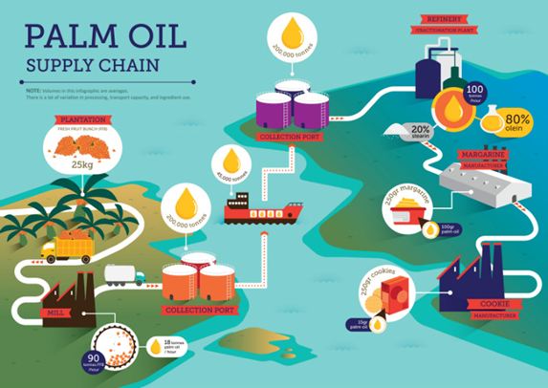

Recent news
Requirements for sustainable palm oil were expanded to cover the following principles:
https://www.rspo.org/news-and-events/news/rspo-members-agree-on-new-palm-oil-standard-to-halt-deforestation-and-improve-human-rights-protection
Halt deforestation by following the high stock carbon approach. Difference between forest areas that should be protected or restored vs land that can be developed. Stops development and clearance of secondary forests.
No new planting on peatlands
Assurances for living wage, job security, no child labour and no forced labour.
What does it not do: ban GMO, toxic pesticides. Also 1 year grace period and some believe standards also need harder enforcement

should we Boycott?
Key campaigners in this field – Greenpeace included – are not arguing for a consumer boycott of all palm oil. It is recognised that pressure from western consumer markets is at least driving some environmental standards into the industry but lots of growth is coming from markets – like those in China and India – without similar demands for environmental standards.
http://www.ethicalconsumer.org/latestnews/entryid/2272/palm-oil-and-consumers-in-2018.aspx

How can we identify palm oil?
Palm Oil has hundreds of different names, many are derivatives of palm oil, manufactured with other chemicals and often used on personal care products. Below we’ve detailed a few examples

Palmitic acid
Palmitic acid, or hexadecanoic acid in IUPAC nomenclature, is the most common saturated fatty acid found in animals, plants and microorganisms.^{[9]} Its chemical formula is CH₃(CH₂)₁₄COOH, and its C:D is 16:0. As its name indicates, it is a major component of the oil from the fruit of oil palms (palm oil). Palmitic acid can also be found in meats, cheeses, butter, and dairy products. Palmitate is the salts and esters of palmitic acid. The palmitate anion is the observed form of palmitic acid at physiologic pH (7.4).
Source: Wikipedia https://en.wikipedia.org/wiki/Palmitic_acid

Palmate and Sodium palmate
Palmitic acid is used to produce soaps, cosmetics, and industrial mold release agents. These applications use sodium palmitate, which is commonly obtained by saponification of palm oil. To this end, palm oil, rendered from palm tree (species Elaeis guineensis), is treated with sodium hydroxide (in the form of caustic soda or lye), which causes hydrolysis of the ester groups, yielding glycerol and sodium palmitate.
Source: wikipedia

Stearic ACid
Stearic acid is obtained from fats and oils by the saponification of the triglycerides using hot water (about 100 °C). The resulting mixture is then distilled.^{[10]}Commercial stearic acid is often a mixture of stearic and palmitic acids, although purified stearic acid is available.
Source: Wikipedia

Palm Stearin
Palm stearin is the solid fraction of palm oil that is produced by partial crystallization at controlled temperature. It is more variable in composition than palmolein, the liquid fraction of palm oil, especially in terms of its solid fat content, and therefore has more variable physical characteristics.

Palm Olein
When the semi-solid palm oil is refined, it separates into palm olein and palm stearine. The palm olein has different characteristics than the palm oil, most notably that it remains completely liquid at room temperature. It is highly heat resistant, similar to palm oil, and it also resists the formation of breakdown products during frying and increases the shelf life of many products.

WWF Palm oil ingredients
https://www.worldwildlife.org/pages/which-everyday-products-contain-palm-oil
INGREDIENTS: Vegetable Oil, Vegetable Fat, Palm Kernel, Palm Kernel Oil, Palm Fruit Oil, Palmate, Palmitate, Palmolein, Glyceryl, Stearate, Stearic Acid, Elaeis Guineensis, Palmitic Acid, Palm Stearine, Palmitoyl Oxostearamide, Palmitoyl Tetrapeptide-3, Sodium Laureth Sulfate, Sodium Lauryl Sulfate, Sodium Kernelate, Sodium Palm Kernelate, Sodium Lauryl Lactylate/Sulphate, Hyrated Palm Glycerides, Etyl Palmitate, Octyl Palmitate, Palmityl Alcohol

